Assignment 1

1. Installing Windows 11

   1. Download Windows 11:

      - Visit the official Microsoft website and download the Windows 11 installation media.

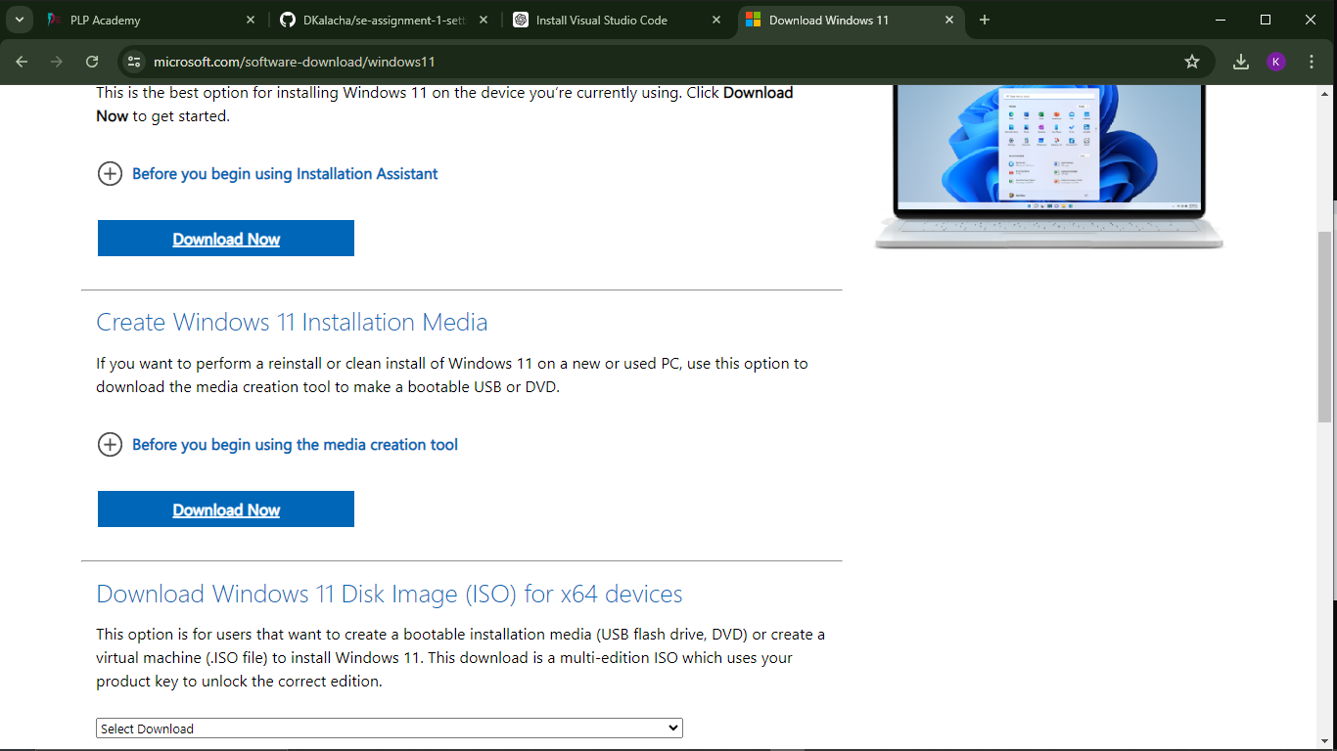

      - Create a bootable USB drive using the Windows Media Creation Tool.

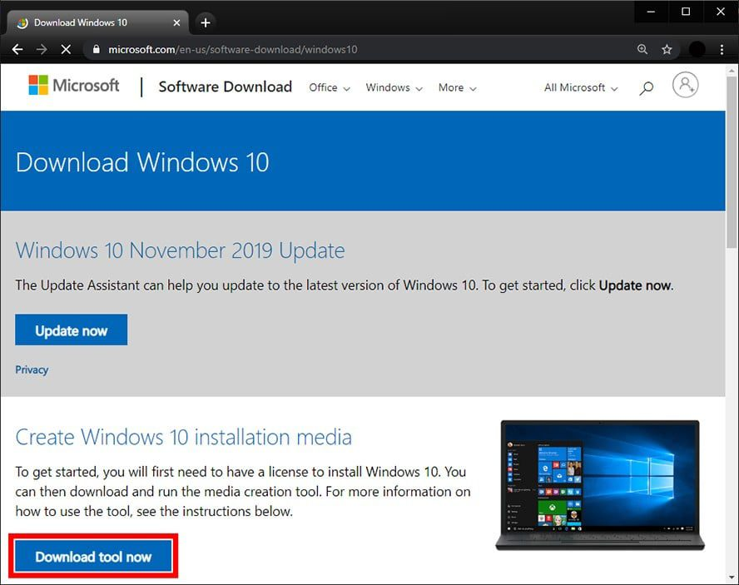

   2. Install Windows 11:

      - Boot from the USB drive and follow the on-screen instructions to install Windows 11.

      - Choose your language, time, and keyboard preferences.

      - Select "Install Now," and enter your product key.

      - Choose the installation type (Upgrade or Custom for a clean install).

      - Follow the prompts to complete the installation.

   3. Post-Installation Setup:

      - Configure your user account and settings.

      - Install necessary drivers and updates via Windows Update.

2. Installing Visual Studio Code

   1. Download VS Code:

      - Visit the Visual Studio Code website(https://code.visualstudio.com/) and download the installer for Windows.

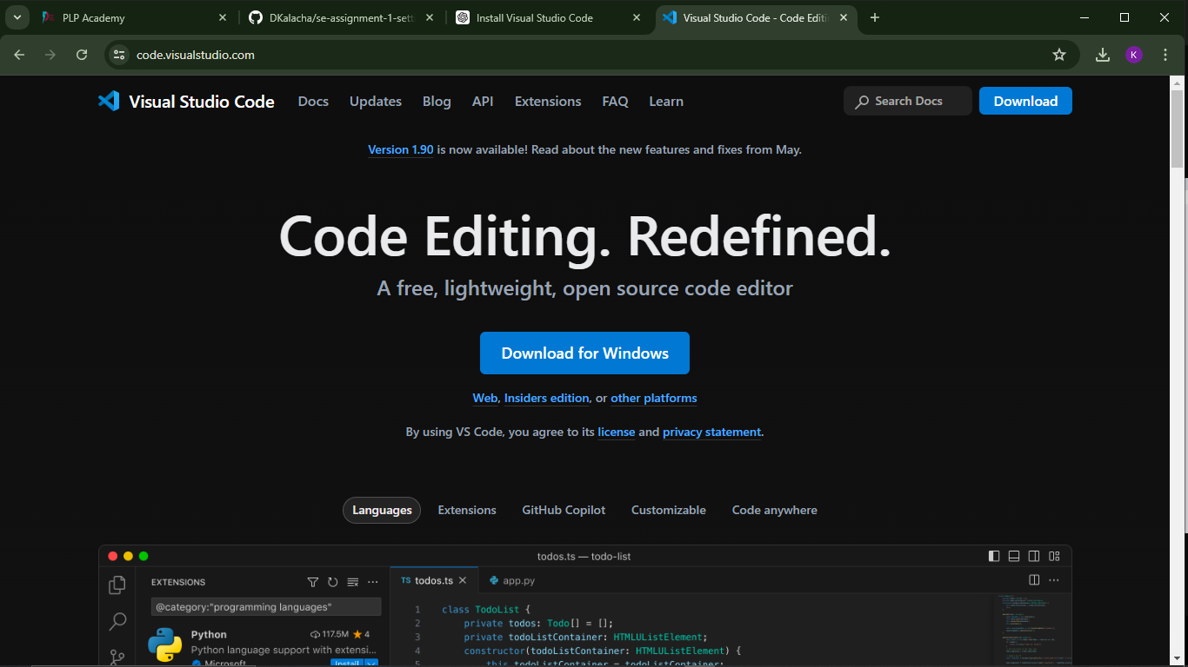

   2. Install VS Code:

      - Run the installer and follow the on-screen instructions.

      - Select the additional tasks you want (like creating a desktop icon or adding VS Code to the PATH).

   3. Initial Configuration:

      - Open VS Code and customize the settings (`Ctrl+,`).

      - Choose a theme by going to `File > Preferences > Color Theme`.

      - Install extensions via the Extensions view (`Ctrl+Shift+X`).

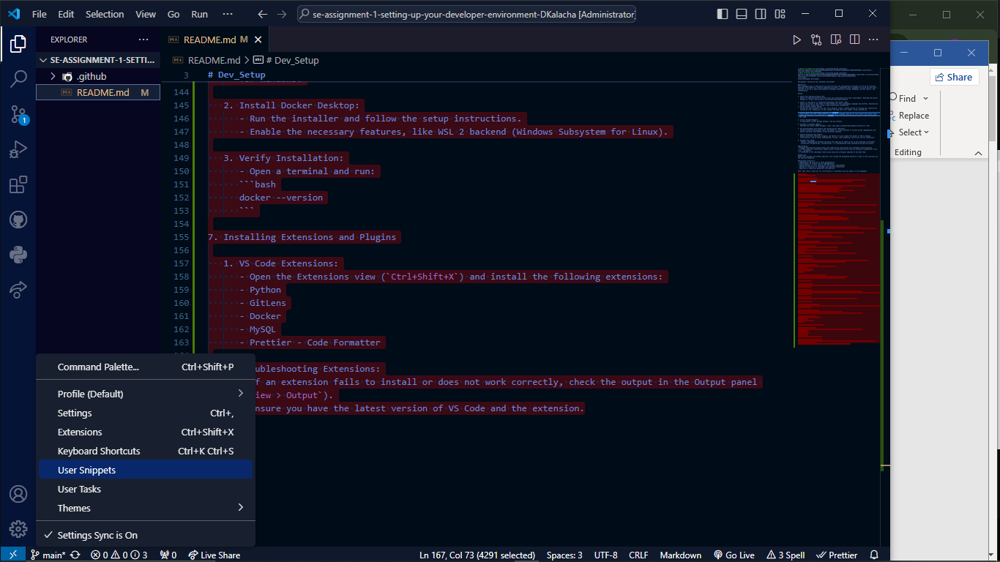

3. Setting Up Git and GitHub

   1. Install Git:

      - Download Git from git-scm.com(https://git-scm.com) and run the installer.

      - Follow the setup instructions, choosing default settings unless specific customizations are needed.

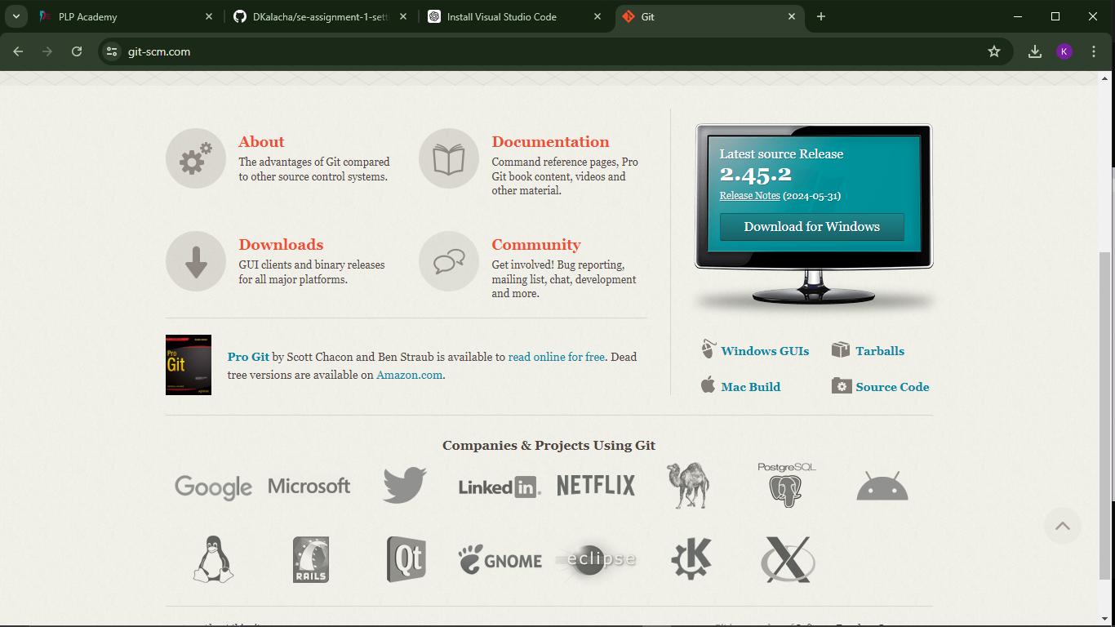

   2. Configure Git:

      - Open a terminal in VS Code(`Ctrl+` backtick), select gitbash as your terminal and set up your user name and email:

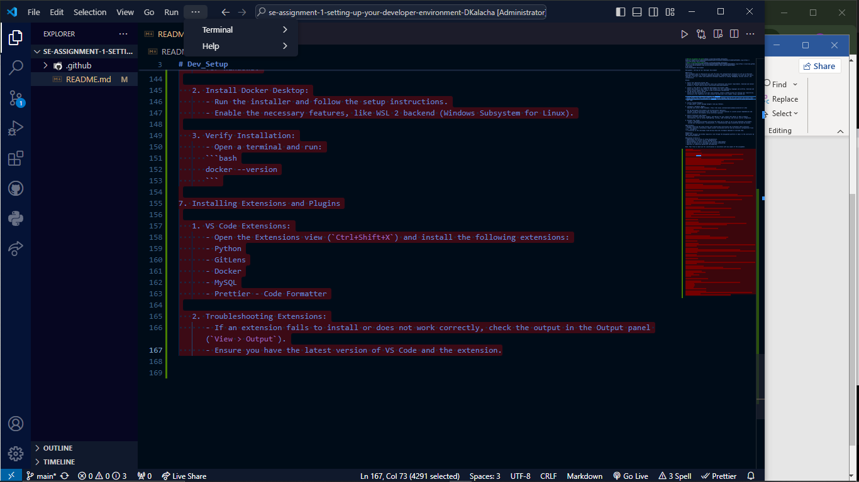

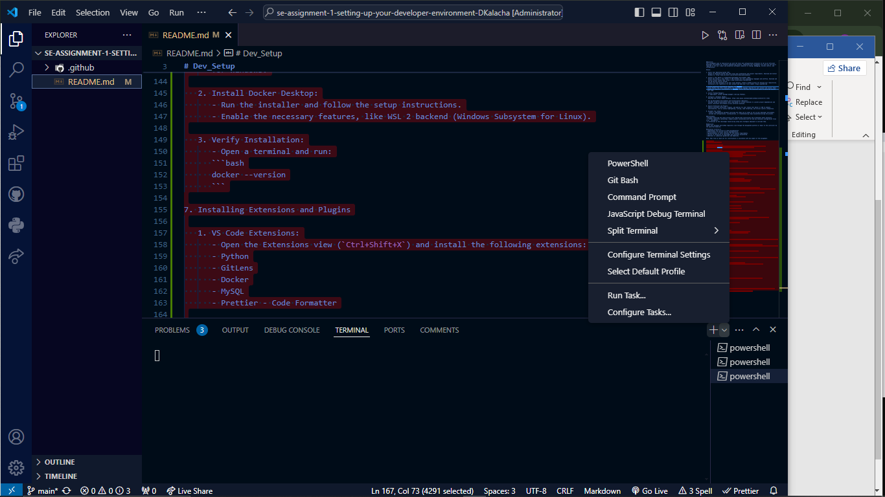

  ```bash

      git config --global user.name "Your Name"

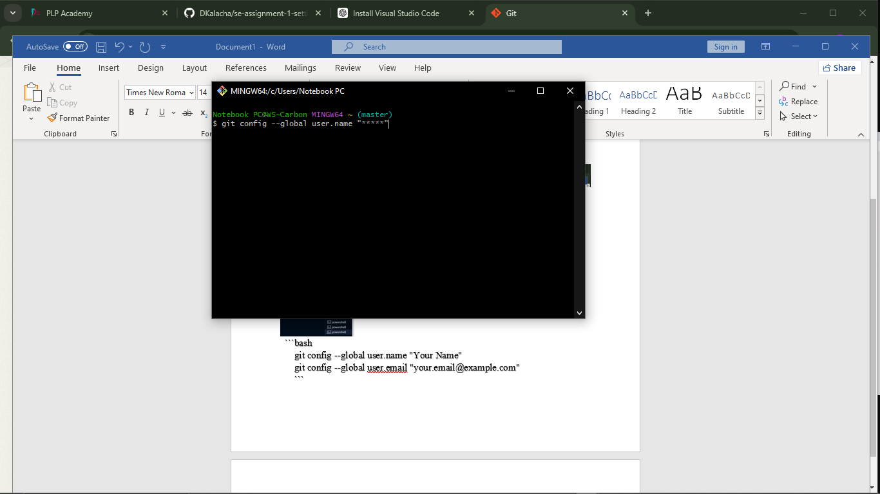

      git config --global user.email "your.email@example.com"

      ```

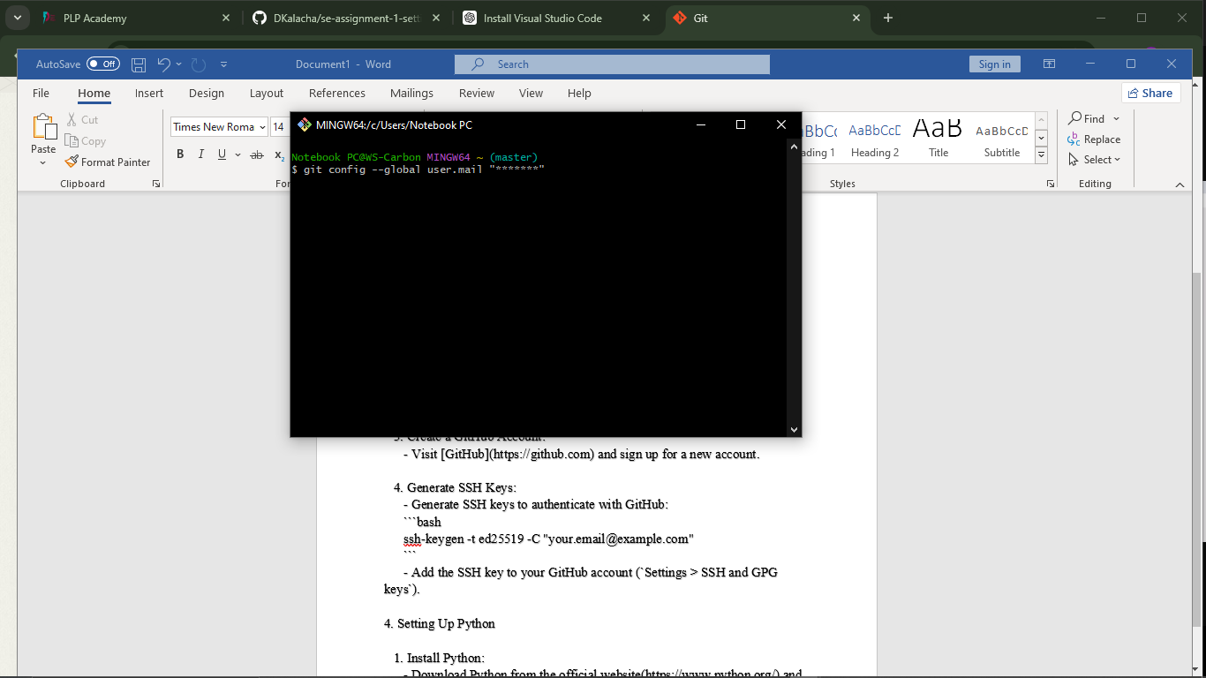

   3. Create a GitHub Account:

      - Visit (https://github.com) and sign up for a new account.

   4. Generate SSH Keys:

      - Generate SSH keys to authenticate with GitHub:

      ```bash

      ssh-keygen -t ed25519 -C "your.email@example.com"

      ```

      - Add the SSH key to your GitHub account (`Settings > SSH and GPG keys`).

4. Setting Up Python

   1. Install Python:

      - Go to the official website(https://www.python.org/) and Download Python by clicking the downloads button and downloading the latest version for windows.

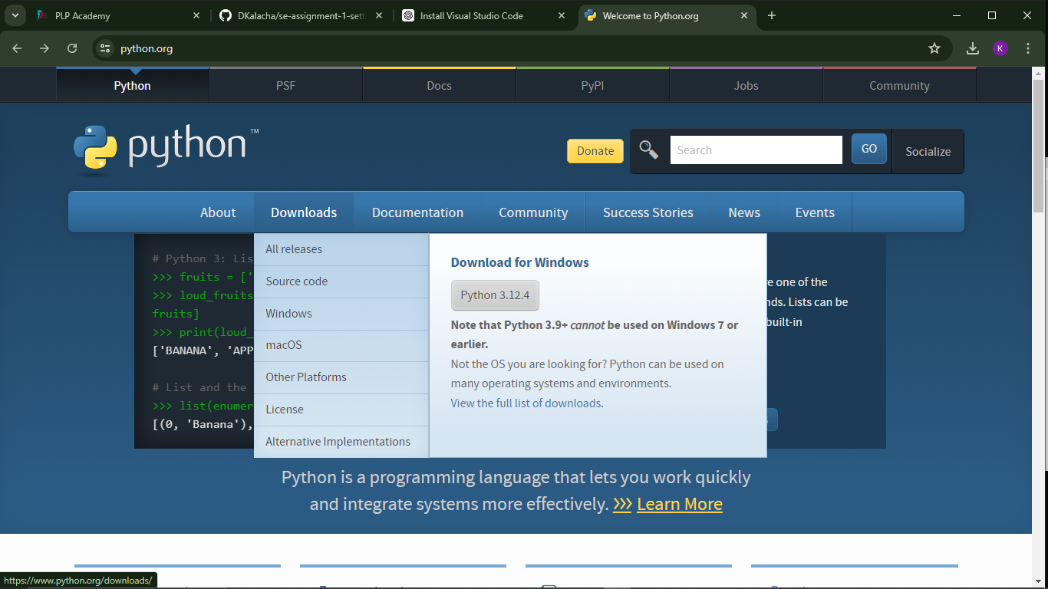

* Run the installer

      - Ensure you check "Add Python to PATH" during installation.

   2. Verify Installation:

      - Open a terminal and verify the installation:

      ```bash

      python --version

      pip --version

      ```

   3. Install VS Code Python Extension:

      - Open VS Code and go to the Extensions view (`Ctrl+Shift+X`).

      - Search for and install the Python extension by Microsoft(first option in the screenshot below)

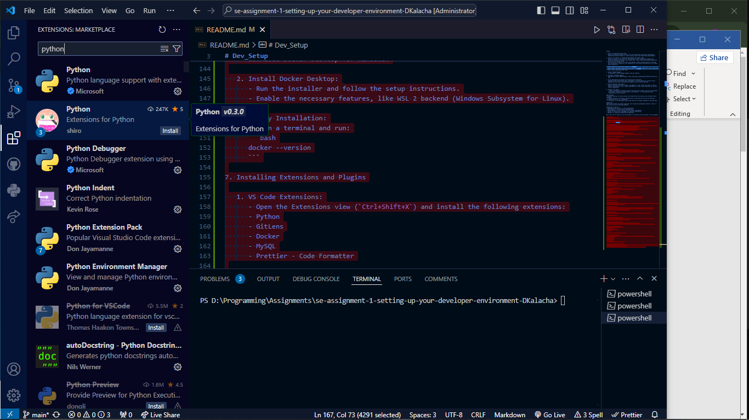

5. Setting Up MySQL

   1. Download MySQL:

      - Visit the MySQL website(https://dev.mysql.com/downloads/installer/) and download the MySQL Installer for Windows(second option which is about 296MB)

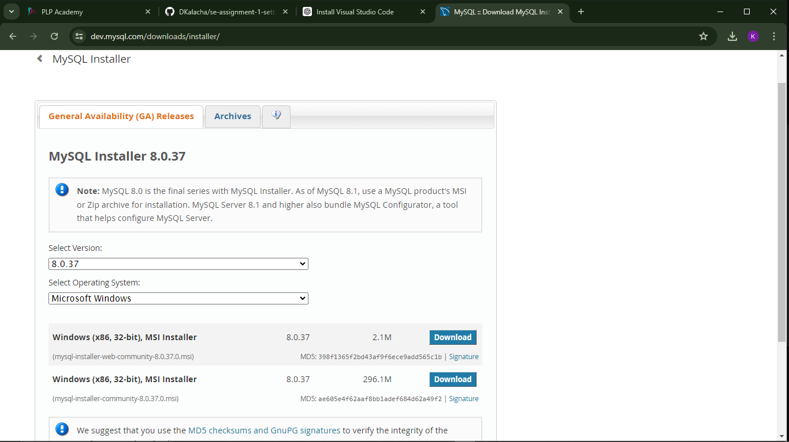

   2. Install MySQL:

      - Run the installer and choose the setup type (Developer Default).

      - Configure your installation by following the steps in the pictures below:

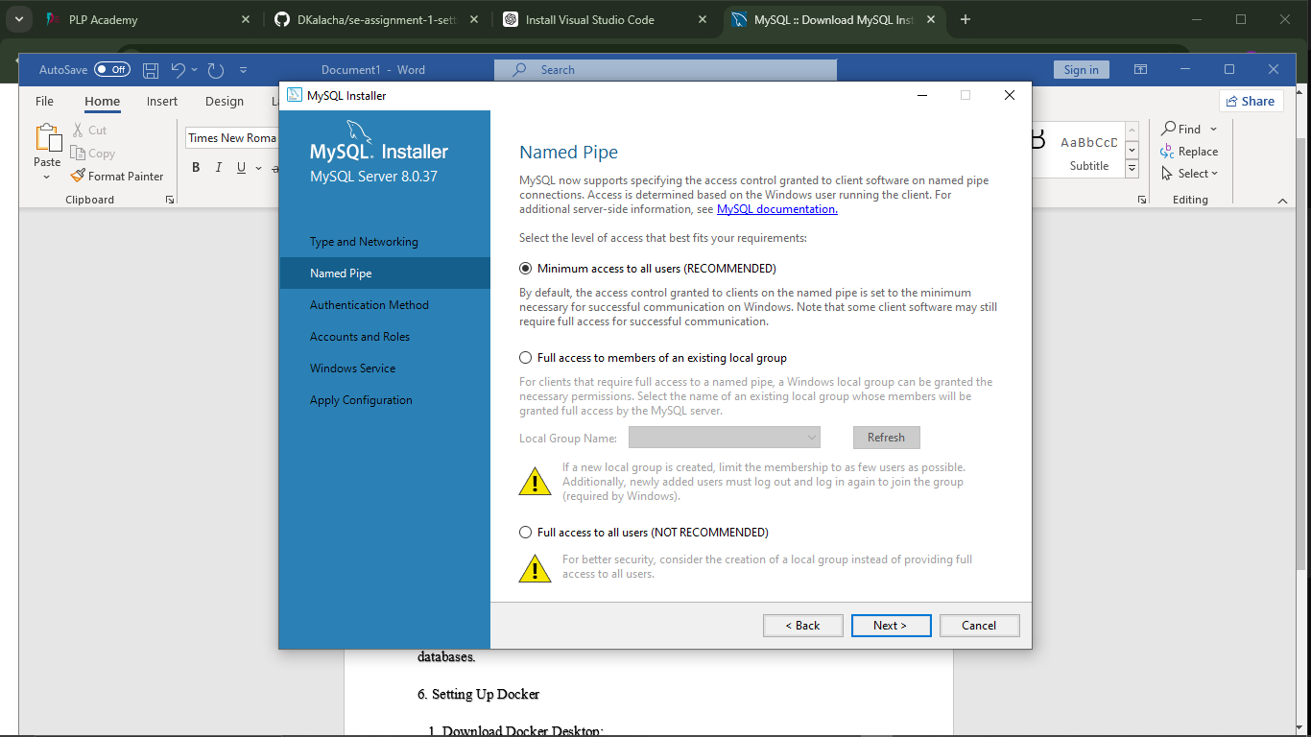

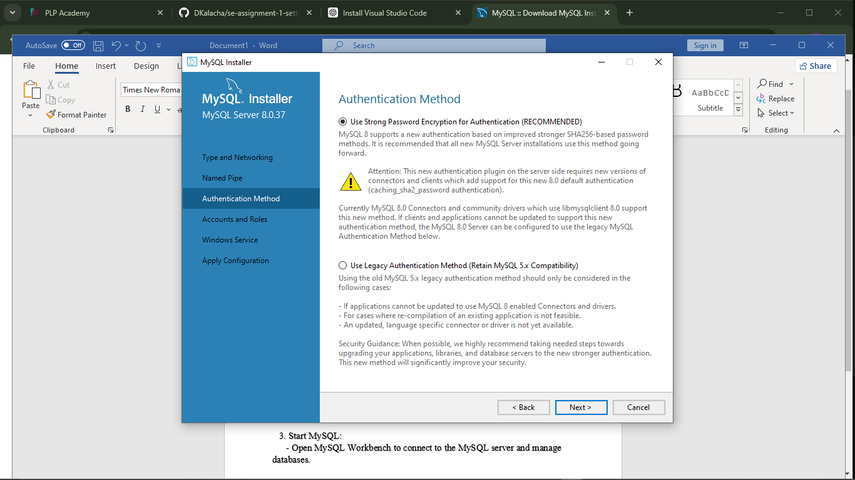

* Create your root password.

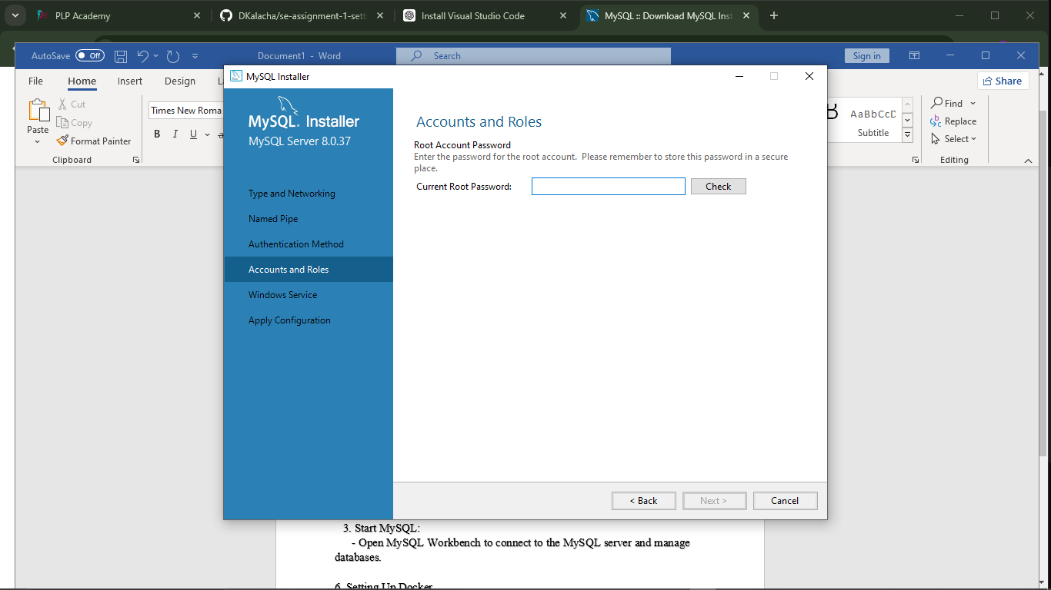

* Configure windows server as a windows service

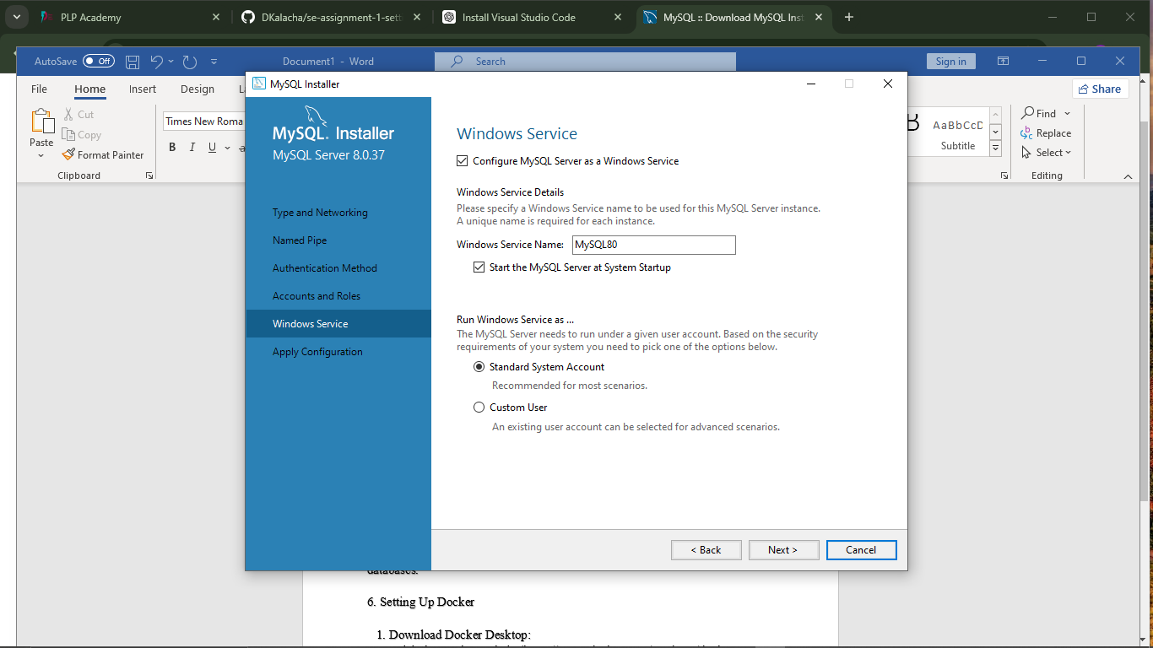

* Execute to implement your installation settings

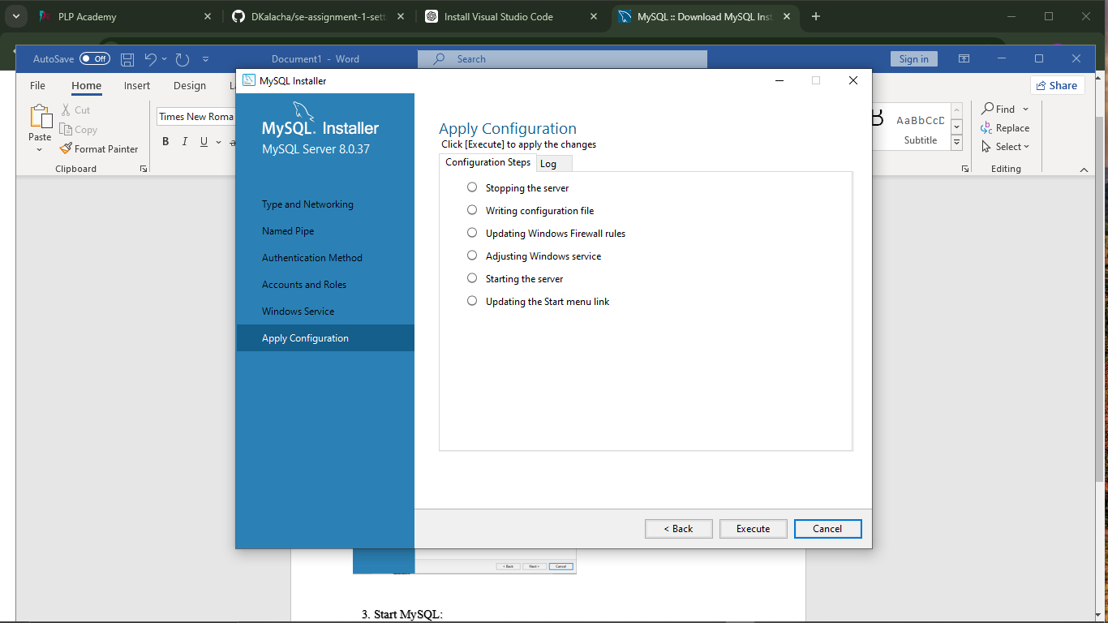

-Download and Install MySQL workbench from the same website ([https://dev.mysql.com/downloads](https://dev.mysql.com/downloads/)/)

N/B I had previously installed MySQL and there are other configuration protocols missing in my screenshots. Please refer to the official MySQL documentation in case of any difficulties.

   3. Start MySQL:

      - Open MySQL Workbench to connect to the MySQL server and manage databases.

6. Setting Up Docker

   1. Download Docker Desktop:

      - Visit the Docker website(<https://www.docker.com/products/docker-desktop>) and download Docker Desktop for Windows.

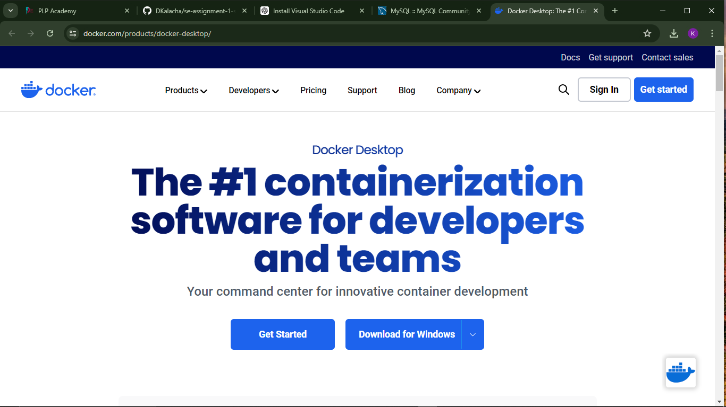

   2. Install Docker Desktop:

      - Run the installer and follow the setup instructions.

      - Enable the necessary features, like WSL 2 backend (Windows Subsystem for Linux).

   3. Verify Installation:

      - Open a terminal and run:

      ```bash

      docker --version

      ```

7. Installing Extensions and Plugins

   1. VS Code Extensions:

      - Open the Extensions view (`Ctrl+Shift+X`) and install the following extensions:

      - Python

      - GitLens

      - Docker

      - MySQL

      - Prettier - Code Formatter

-VS code icons

   2. Troubleshooting Extensions:

      - If an extension fails to install or does not work correctly, check the output in the Output panel (`View > Output`).

      - Ensure you have the latest version of VS Code and the extension.